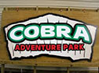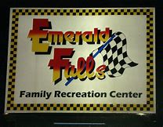

ARMBANDS
$40.00
Good for players, parents, siblings & all fans!
Available for pre-purchase through team pre-orders! Also available on site at Frank Brown Park, Coaches Meetings, Opening Ceremonies & Pin Trading Event!

UNLIMITED Rides* and Mini Golf for BOTH PARKS! Sunday through Sunday of your tournament!
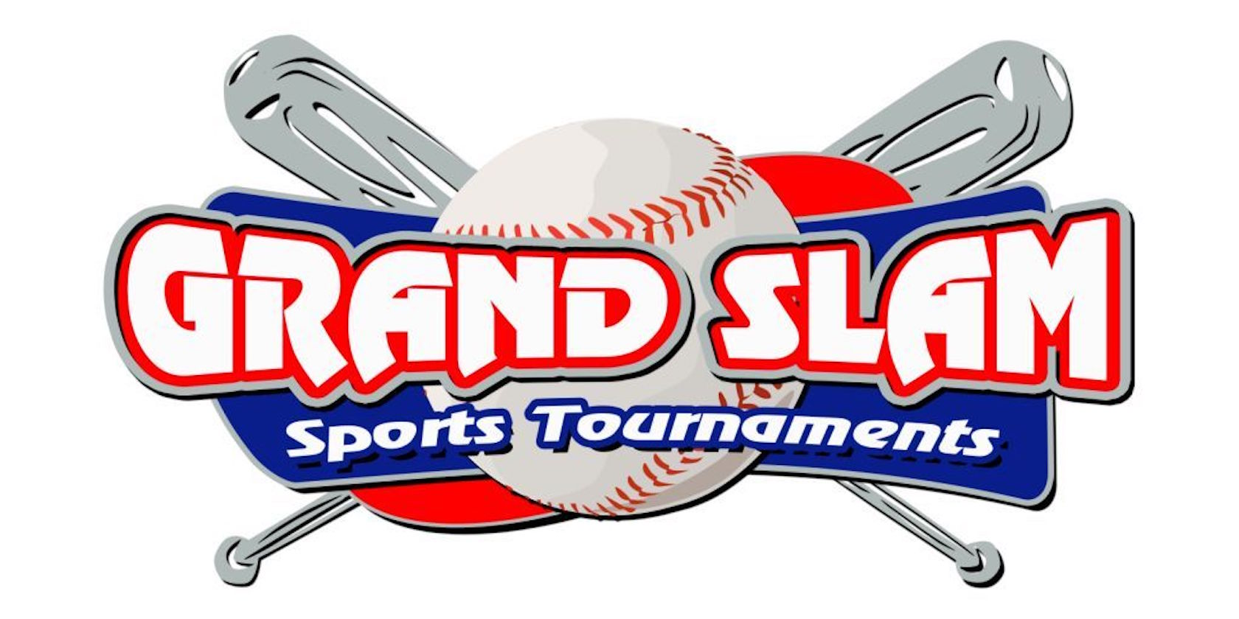
*Excludes Extreme rides & coin operated machines. Park operational height & weight rules apply!

