The 2023 Grand Slam World Series of Baseball Merchandise Pre-Order Form
** Payment is due when items are picked up at the Coaches meetings. Please check what WS you are attending.
_____ World Series Session I (June 19-25, 2023) _____ World Series Session II (June 26-July 1, 2023)
_____ World Series Session III (July 3-9, 2023) _____ World Series Session IV (July 24-30, 2023)
Team Name: _______________ Age Division: _____ Contact Person & Cell: ______________________
This is for TEAM ORDERS ONLY! We CANNOT TAKE INDIVIDUAL PARENTS/PLAYERS ORDERS!
Team Moms/Coaches need to do ONE TEAM ORDER ONLY to be paid for and picked up at the Coaches Meetings on the day prior
to the start of the event! Please Scan, Print, Fill out and email to grandslamtournaments@gmail.com
DEADLINE FOR PRE-ORDERS is WS 1: 6/2; WS 2: 6/9; WS 3: 6/16 and WS 4: 7/7
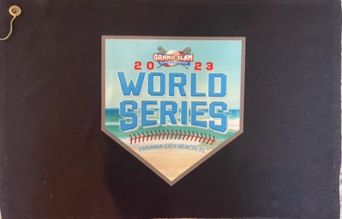

Please put the # of items you want in the spaces below:
The 2023 Grand Slam World Series of Baseball Official Logo Tournament T-Shirts (Shirts are Dri-Fit material) ($30 each for YM-AXL; $35 for AXXL & A3X)
_____ YM Black _____ YL Black _____ YXL Black _____ AS Black _____ AM Black _____ AL Black _____ AXL Black _____ AXXL Black _____ A3X Black
_____ YM Gray _____ YL Gray _____ YXL Gray _____ AS Gray _____ AM Gray _____ AL Gray _____ AXL Gray _____ AXXL Gray _____ A3X Gray
_____ YM White _____ YL White _____ YXL White _____ AS White _____ AM White _____ AL White _____ AXL White _____ AXXL White _____ A3X White
_____ YM Teal _____ YL Teal _____ YXL Teal _____ AS Teal _____ AM Teal _____ AL Teal _____ AXL Teal_____ AXXL Teal _____ A3X Teal
The 2023 Grand Slam World Series of Baseball Official Logo Pin, WS Logo Pin and WS Logo Trading Towels ($25 towels; $5 Pins; $30 Towel & pin Combo
_____ World Series Logo Towels (Black in Color with full WS Logo embroidered) _____ World Series Logo Trading Pin
_____ Grand Slam Logo Trading Pin
_____ Towel & both pins combo
Total Amount Due: (This part to be filled out by Grand Slam Only)
_____ Shirts @ $30 _____ Shirts @ $35 _____ Towels @ $25 _____ WS Pins @ $5 _____ GS Pins @ $5 _____ Towel/Pin Combo @ $30 TOTAL DUE: __________

