 

***The 2023 Grand Slam Future Prospects Winter Games***

***Apparel Pre-Order Form***

***\*\*\* Grand Slam will be offering for Pre-Order, Official Grand Slam Future Prospects Logo***

***BLACK Dri-Fit Long Sleeve T-Shirts (Pictured Below) and Official Grand Slam Corporate Logo BLACK or GRAY Hoodies (Blank hoodie pictured below but will have the Grand Slam Corporate Full color logo on the front. Please fill out the form below indicating the # of each that you would like to preorder, print, scan and email to*** [***grandslamtournaments@gmail.com***](mailto:grandslamtournaments@gmail.com) ***by the Pre-Order Deadline of Friday, December 30, 2022.***

***($30.00 each) 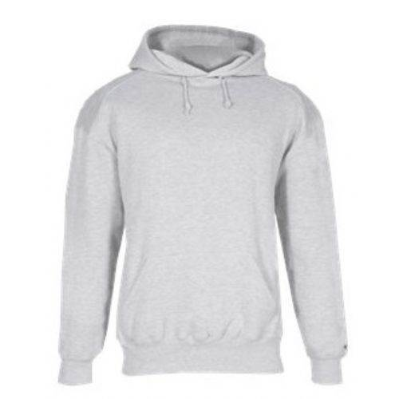 ($45.00 each)*** 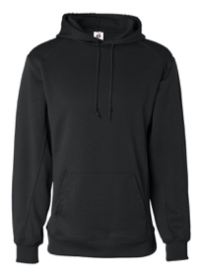

***YM: _____ YM G: _____ YM B: _____***

***YL: _____ YL G: _____ YL B: _____***

***YXL: _____ YXL G: _____ YXL B: _____***

***AS: _____ AS G: _____ AS B: _____***

***AM: _____ AM G: _____ AM B: _____***

***AL: _____ AL G: _____ AL B: _____***

***AXL: _____ AXL G: _____ AXL B: _____***

***A2X: _____ A2X G: _____ A2X B: _____***

***A3X: _____ A3X G: _____ A3X B: _____***

***Name: _____________________________ Cell Number: ____________________***

***Mailing Address: ________________________________________________________***

***\*\*\* You will pick up your pre-order on either Friday night at Player Registration OR on Saturday morning at the Publix Sports Park. Card or Cash Payment ONLY!***

***For Office Use ONLY: Total Amount Due: __________***