**The 2020 Grand Slam World Series of Baseball Merchandise Pre-Order Form**

**\*\* Payment is due when items are picked up at the Coaches meetings. Please check what WS you are attending.**

**_____ World Series Session I (June 15-21, 2020) Deadline to Pre-order is Wednesday, June 10, 2020**

**_____ World Series Sesson II (June 22-28, 2020) Deadline to Pre-order is Wednesday, June 17, 2020**

**_____ World Series Session III (June 29-July 5, 2020) Deadline to Pre-order is Wednesday, June 24, 2020**

**_____ World Series Session IV (July 20-26, 2020) Deadline to Pre-order is Wednesday, July 15, 2020**

**Team Name: _______________ Age Division: _____ Contact Person & Cell: ______________________**

**Please put the # of items you want in the spaces below:**

**The 2020 Grand Slam World Series of Baseball Official Logo Tournament T-Shirts**

**(Shirts are Dri-Fit material) ($25 each for YM-YXL; $30 for AXXL & A3X)**

**_____ YM Gray _____ YM Red**

**_____ YL Gray _____ YL Red**

**_____ YXL Gray _____ YXL Red**

**_____ AS Gray _____ AS Red**

**_____ AM Gray _____ AM Red**

**_____ AL Gray _____ AL Red**

**_____ AXL Gray _____ AXL Red**

**_____ AXXL Gray _____ AXXL Red**

**_____ A3X Gray _____ A3X Red**

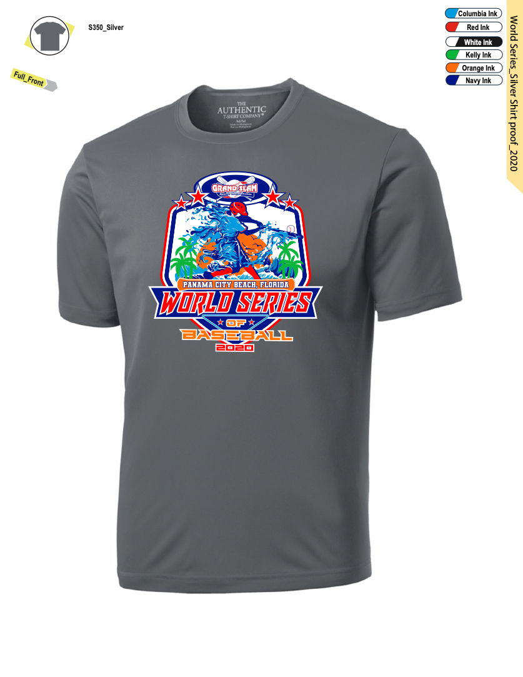 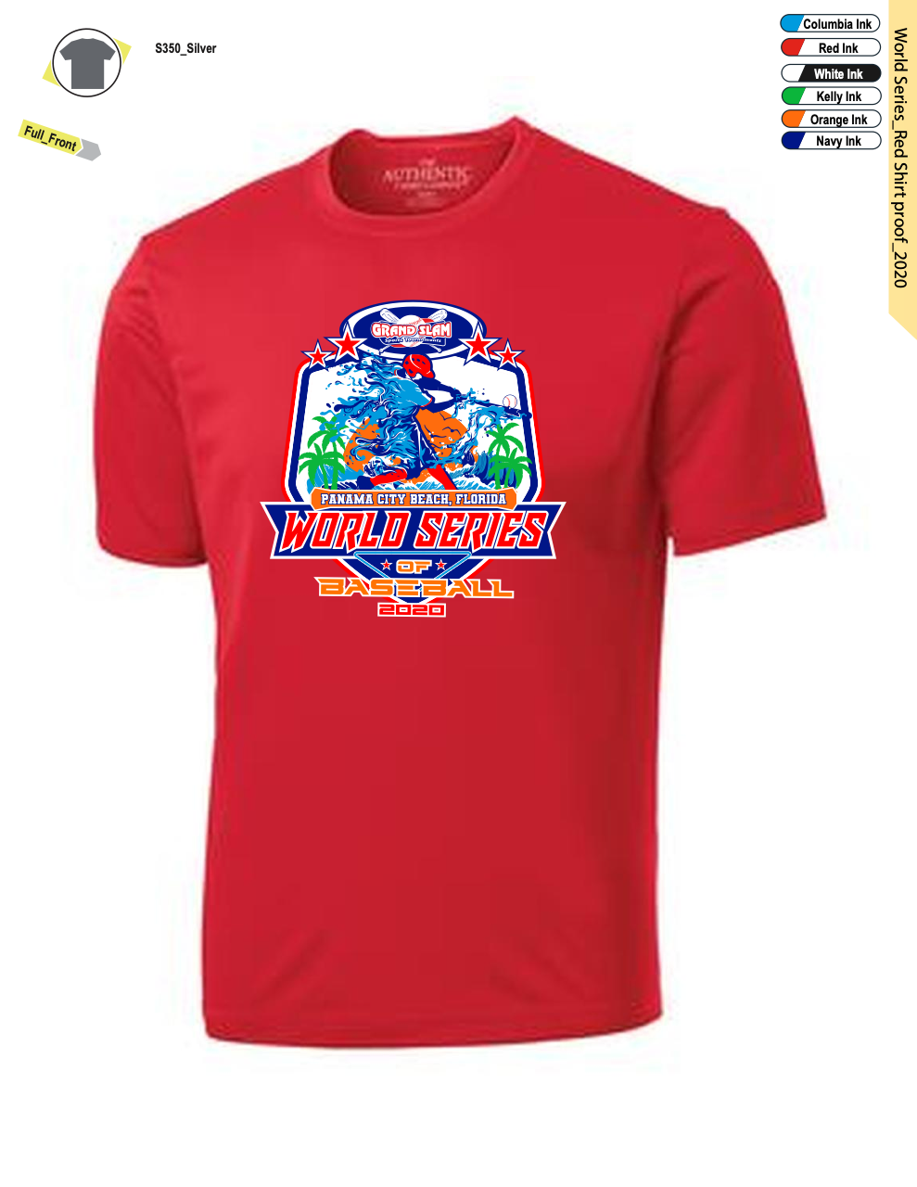

**The 2020 Grand Slam World Series of Baseball Official Logo Pin Trading Towels, Pins & Collectible Coin**

**($15 towels; $5 Pins; $20 Towel & pin Combo; $15 Collectible Coin)**

**_____ World Series Logo Towels (Navy Blue) _____ Collectible Coin (2-ounces & 2x2 in size)**

**_____ World Series Logo Trading Pin**

**_____ Grand Slam Logo Trading Pin**

**_____ Towel & both pins combo**

 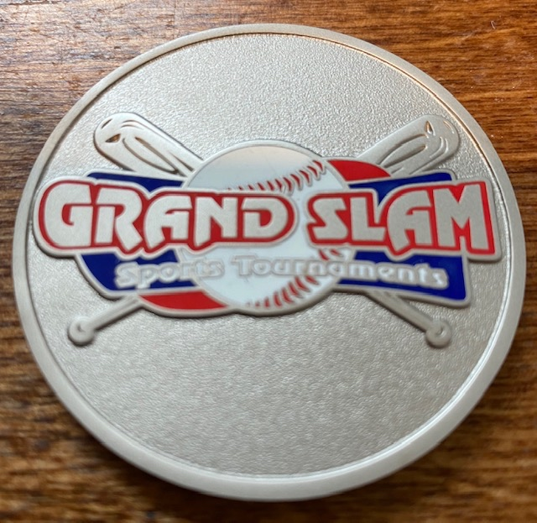 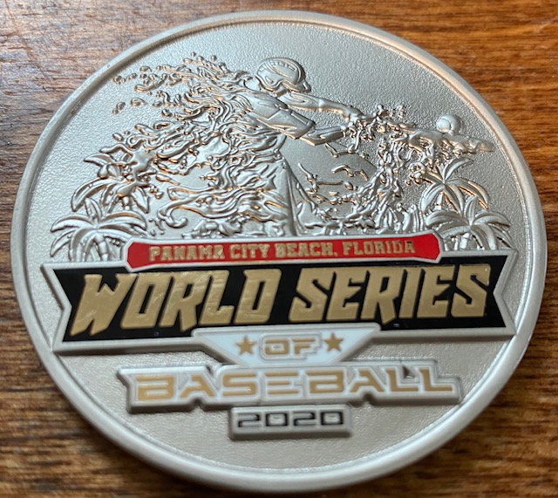

**Total Amount Due: (This part to be filled out by Grand Slam Only)**

**_____ Shirts @ $25 _____ Shirts @ $30 _____ Towels @ $15 _____ WS Pins @ $5 _____ GS Pins @ $5**

**_____ Towel/Pin Combo @ $20 _____ Collectible Coin @ $15 TOTAL DUE: __________**

**\*\*\*\*\* We will also have The Game Logo Hats available at Opening Ceremonies and the park!**